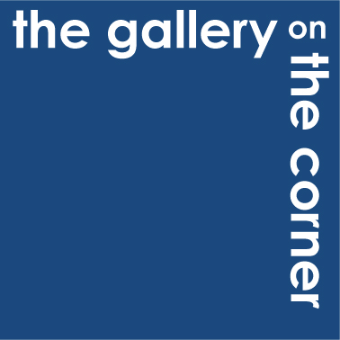

Submission Pack

The Gallery on the Corner provides a platform to exhibit and sell artwork produced by artists who have a physical or mental health condition, or those from a disadvantaged background, in a high profile location in the heart of Edinburgh’s gallery district.

Guidance Notes

Who can apply?

- Any artist or group of artists who have a physical or mental health condition or are from a disadvantaged background.

What kind of work are we looking for?

- High quality, original, commercial artwork; drawings, paintings, sculpture and other relevant artwork.

What do we need from you?

- A completed submission form
- A selection of electronic images of artwork (minimum of five per artist) by email or on CD

How does the selection process work?

- The gallery management team will make recommendations to the gallery selection committee. The selection committee meets regularly to assess artwork for the gallery
- If artwork is selected by the committee gallery staff will arrange a meeting with the artist/ artist’s representative/ art group to view the work as part of the final selection process.
- If artwork is chosen for exhibition it is the artist’s responsibility to arrange delivery of work to the gallery.
Terms and Conditions

- Consignment of work

Artists must ensure that all work consigned to The Gallery on the Corner is professionally mounted and/ or framed. Framed work should be ready for hanging e.g. string on the back. Mounted work should be wrapped in cellophane.

The gallery will provide artists with a receipt for artwork consigned to the gallery.

Artwork is taken to be accepted in good condition unless any particular defects are noted on the receipt.

Consignment of artwork is not a guarantee that your work will be exhibited.

- Selling prices

The selling price of each piece of work will be recorded on the receipt.

Possible discounts to customers will be discussed with artists before a sale e.g. 10% discount for regular customers.

- Gallery commission

The agreed rate of sales commission which the gallery will receive on any sale is 40%.

- Duration

The artwork stated on the receipt will be consigned to the gallery for a maximum of three months. After three months the consignment will be reviewed and a decision will be made between the gallery and artist as to whether the work will stay in the gallery for an extended period of time.

- Delivery/ collection arrangements

Artwork should be delivered to the gallery by the artist, or artist’s representative.

Artwork should be collected from the gallery by the artist, or artist’s representative.

- Ownership of work and copyright

The artwork stated on the receipt remains the property of the artist until sold, or returned to the artist.

The artist remains copyright owner.

The gallery has the right to use artwork images provided by the artist in all gallery marketing material e.g. flyers, posters, websites and social media.

- Insurance

All artwork is insured whilst consigned to the gallery, up to a value of £1500 per piece.

- VAT

Artists that are registered for VAT must provide the gallery with their VAT number on delivery of artwork to the gallery.

At the present time, the gallery is not VAT registered. If, in the future, the gallery does register for VAT, the gallery will add on VAT to its 40% commission charge only. This charge is in respect of the gallery’s service of acting as a disclosed selling agent for the artist.

Any VAT due to HMRC in respect of the sale of the artwork by the artist is the responsibility of the artist to account for to HMRC. The gallery will not be liable for any VAT, penalties and/ or interest due in respect of the sale of the artwork by the artist.

- Payment

The gallery will issues memos in the name of, and on the behalf of, the artist for the sale of the artwork by the artist to the gallery’s Finance Department. The Finance Department will organise BACS payments for 60% of the selling price of the artwork to the artist’s bank account within 3 months of the artist’s artwork selling. All such memos will be treated as being for a sales amount inclusive of any VAT due to HMRC from the artist.

Submission Form
Artist Name
Email
Address
Phone Number
Mobile Number
Eligibility
Tell us about your eligibility to exhibit your work at the gallery
Artist or Group Statement
Tell us about your work as an artist or exhibition proposal

REMEMBER TO SUBMIT ELECTRONIC IMAGES OF YOUR ARTWORK ALONG WITH YOUR SUBMISSION FORM

